Project Report

|  |  |
| --- | --- |
| Project Title | Problem Manage a Server Outage Scenario & an Issue & Change Request Management System |
| Qualification Name (NICF) | Advanced Certificate in Software Applications (Development and Deployment) |
| Product Name |  |
| Module Name (NICF) |  |

|  |  |  |  |
| --- | --- | --- | --- |
| Student name | | Assessor name | |
| Agung Yuda Pratama | |  | |
| Date issued | Completion date | | Submitted on |
|  |  | |  |
|  | |  | |
| Project title | Student Registration Form Development | | |

|  |
| --- |
| Learner declaration |
| I certify that the work submitted for this assignment is my own and research sources are fully acknowledged.    Student signature: Date: 18 August 2023 |

Table of Contents

1. Project Background 2

2. Project Objective 3

3. Project Requirements Specifications 4

3.1 Functional requirements 4

3.2 Non-functional requirements 5

4. Task 1: Principles of Problem Management 6

4.1 What is Problem Management? 6

4.2 The Three Phases of Problem Management 6

4.3 Principles of Problem Management 7

4.4 Problem Management Example 8

5. Task 2: Tools, Process & Technologies 9

1. Problem Logging 9

6. Task 3: Investigate & Diagnose 10

7. Task 4: Explain Prioritize 11

Priorities and categories problems: 11

8. Task 5: Problem Management Solution 13

9. Task 6: Systems will be implemented 13

10. Task 7: Best Practices in Problem Management 14

# Project Background

Developing a Software Developer's Community Portal

ABC Jobs Pte Ltd is embarking on a transformative project to establish a dedicated community portal for software developers akin to LinkedIn. This initiative aims to create a hub where programmers and software administrators can seamlessly connect, exhibit their skills, explore job prospects, and collaborate on projects. This project aligns with the framework of the NICF-Capstone Project using Java, leveraging knowledge from previous modules, including UI Framework, Database Design, and Web Development Foundation.

The project's overarching objectives are twofold: firstly, it requires participants to design, plan, and rigorously test the community portal developed during Module 5, showcasing their ability to synthesize skills acquired throughout the course. Secondly, the project addresses the recurrent downtime experienced by ABC Jobs Pte Ltd's existing community website. By implementing problem management principles and utilizing cutting-edge tools and technologies, the project aims to resolve these issues and establish a sustainable solution. The project endeavors to enhance incident and enhancement management practices through meticulous documentation, adherence to best practices, and nurture a dynamic software developer community.

The development of this community portal underscores the intersection of technological proficiency and real-world problem-solving. It provides a tangible platform for software professionals to collaborate and flourish and exemplifies the participants' capacity to translate theoretical knowledge into practical solutions that have a lasting impact on a vital industry.

**Scope of the project**

* Explain the principles of problem management.
* Use a variety of tools, processes and techniques to identify problems.
* Conduct investigation, analysis and resolution.
* Explain the steps to investigate and diagnose problems.
* Prioritise and classify change requests.
* Prepare a solution to address the root cause of the problem.
* Document and monitor problems
* Explain best practice for documenting problems.

# Project Objective

The project objective is to effectively manage and address issues related to the community portal by implementing a problem-management framework. This involves identifying, investigating, and resolving problems to enhance the stability and performance of the website. The goal is to streamline incident and change request management, prioritize issues, propose solutions, and establish a robust problem documentation process.

**Tools & Platforms Used**

a. **IntelliJ IDEA**

* Purpose: Used as the primary integrated development environment (IDE) for developing Java-based software tools.
* Function: Provides a comprehensive platform for coding, debugging, and testing Java programs, ensuring efficient development and maintenance of the community portal.

c. **Microsoft Word**

* Purpose: Employed to create the Problem Management Report.
* Function: Allows the creation of detailed and structured reports that document the problem management process, including the identification, analysis, and resolution of issues related to the community portal.

d. **Figma**

* Purpose: Utilized to create visual diagrams, For Brainstorming, for root cause analysis.
* Function: Enables the creation of clear and organized diagrams that help analyze the root causes of problems. Specifically, fishbone diagrams aid in identifying underlying factors contributing to issues in the community portal.

Utilizing these tools and platforms, the project aims to efficiently develop, manage, and document the problem management process, leading to an improved and more reliable community portal for software developers.

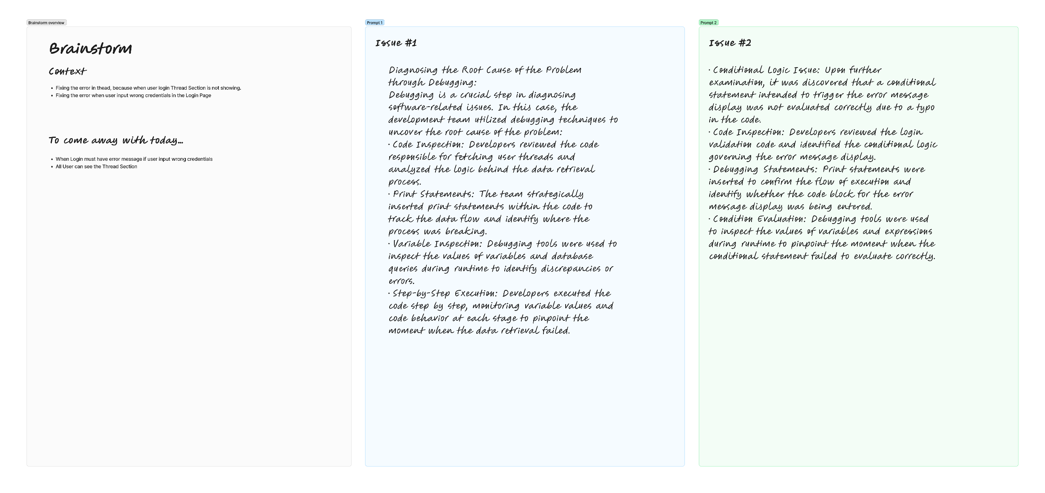

# Project Requirements Specifications

## ****3.1 Functional requirements****

**Users (Software Programmer)**

**Register:** New Software Programmers can create an account and register on the community portal.

**Login:** Software Programmers can log in to their accounts using their credentials

**Logout:** Software Programmers can log out of their accounts to end their session.

**Posting Thread: Software Programmers should be able to post on their dashboard**

**Comment on Thread: Software Programmers should be able to comment on threads.**

**Search users:** The Software programmers can search for other users by parameters like First Name, Last Name, City.

**View Other Users: Software Programmers can view other profiles after searching it.**

**Update profile:** Software Programmers can edit and update their profile information.

**Apply Jobs: Software Programmers can apply job that already post by Admin.**

**Administrator**

**Login:** Administrators can access their accounts with their login information.

**Add user:** To end their session, administrators can log out of their accounts.

**Delete user: admin can delete user data that has registered on the portal.**

**Modify user:** The admin can update the data of registered users on the portal.

**Send Bulk Email: The admin can send Bulk Emails to the users in the community portal.**

**Post Jobs: The admin can post the jobs in the community portal.**

## ****3.2 Non-functional requirements****

**Safety Requirements:**

The community portal project has specific safety requirements due to the sensitive nature of user data:

1. **Data Privacy and Security:** The database contains the personal information of users, necessitating robust data privacy and security measures. Ensure compliance with relevant data protection regulations and implement encryption and access controls to safeguard user data from unauthorized access or breaches.
2. **Audit Trails and Logging:** Implement comprehensive audit trails and logging mechanisms to track user interactions and system activities. This helps monitor and investigate potential security breaches or unauthorized access attempts.

**Performance Attributes:**

1. **Availability:** The community portal aims to achieve high availability to ensure uninterrupted user access. Implement load balancing, redundancy, and failover mechanisms to minimize downtime in case of server failures. Regularly conduct disaster recovery drills to ensure swift recovery during unexpected incidents.
2. **Maintainability:** The administrator should regularly monitor and maintain the community portal to ensure optimal performance. Schedule routine maintenance tasks, such as database backups, software updates, and performance optimization, to enhance the portal's stability and longevity.
3. **Usability:** The ABC community portal is designed to accommodate many users and a substantial amount of user information. To ensure usability:
   * **Scalability:** Design the system to handle increased user load and data growth. Implement horizontal scaling by adding more servers or resources as needed.
   * **User-Friendly Interface:** Develop intuitive and user-friendly interfaces that enable users to navigate portals, find information quickly, and perform tasks efficiently.
   * **Responsive Design:** Ensure the portal design is responsive and adaptable to various devices and screen sizes, enhancing the user experience across multiple platforms.
   * **Efficient Search and Retrieval:** Implement efficient search and retrieval mechanisms to enable users to access their desired information quickly, even as the database grows.
   * **Optimized Performance:** Utilize caching mechanisms, minimize database queries, and employ content delivery networks (CDNs) to optimize page load times and overall performance.

By addressing these non-functional requirements, the project ensures the community portal's safety, performance, availability, maintainability, and usability. These requirements contribute to delivering a reliable and user-friendly experience for administrators and users of the ABC community portal.

# Task 1: Principles of Problem Management

## 4.1 What is Problem Management?

Problem Management is a proactive process in IT service management that aims to identify, investigate, analyze and resolve the root causes of incidents and problems. The focus is on addressing the root causes of recurring issues, minimizing their impact on services, and preventing similar occurrences in the future.

## 4.2 The Three Phases of Problem Management

1. Problem Identification

This phase signifies the early recognition of potential issues that may affect IT services. This involves leveraging sources such as incident reports, trend analysis and user feedback to proactively identify potential problems and prevent their escalation.

* **Incident Reports:** Monitoring and analyzing incident reports helps in identifying recurring patterns or issues that may indicate an underlying problem.
* **Trend Analysis:** Examining historical data and trends can reveal anomalies or deviations that can lead to potential problems.
* **User Feedback:** Gathering feedback from users can provide insight into their experience, uncovering issues before they become a major concern.

1. Problem Control

Immediate steps are taken at this stage to temporarily reduce the impact of the known problem or prevent its damage. Quick solutions are implemented, such as isolating the problematic component or implementing temporary fixes, until a permanent solution is established.

* **Component Isolation:** If a particular component is causing problems, isolating it can prevent its negative impact from spreading to other parts of the system.
* **Temporary Fix:** Implementing a workaround or workaround can quickly restore functionality while a more permanent resolution is being developed.
* **Service Continuity:** The focus is on maintaining service availability and functionality while minimizing disruption caused by issues.

1. Error Control

Effective problem management also includes managing errors in their workflows. Proper tracking, reporting, and correcting errors during the problem management process is critical to ensuring process integrity.

* **Error Tracking:** Logging errors and problems encountered during problem management allows for a systematic understanding of where problems may occur in the process.
* **Error Reporting:** Transparently communicating errors to the relevant team ensures that issues are recognized and can be dealt with efficiently.
* **Error Correction:** Correcting errors in a timely manner prevents them from spreading further and maintains the accuracy and reliability of the entire problem management process.

## 4.3 Principles of Problem Management

1. Problem Identification

• Sources of Identification: Problem identification can come from user reporting, system monitoring, and analysis of operational data.

• Initial Categorization: The identified problems are given an initial category based on their type or impact, assisting in the shifting of treatment priorities.

1. Problem Investigation

High priority or high-risk problems should be resolved first, as their impact on the service is highest. The speed at which problems are investigated and diagnosed depends on the priority assigned. Correctly categorising problems makes it easier to identify trends.

* **Investigation Priority:** Issues with high impact or high risk receive higher priority in the investigation process.
* **Data Analysis:** Incident data and other information is analyzed to identify patterns or trends that can assist in investigations.
* **Source Identification:** The main aim of an investigation is to identify the underlying source of the problem.

1. Problem Analysis

* **RCA (Root Cause Analysis):** Involves an in-depth analysis method to identify the root cause of the problem, not just the surface symptoms.
* **Recovery Measures:** More effective and permanent recovery measures are planned based on the analysis.

1. Problem Resolution

• Solution Development: The problem team designs a solution that focuses on addressing the root cause of the problem.

• Change Deployment: The change is implemented, and the service is returned to its normal state with the new solution being implemented.

1. Review

• Effectiveness Evaluation: Evaluation is conducted to ensure that the implemented solution actually addresses the problem.

• Lessons Learned: Lessons from this issue are documented to improve the problem management process in the future.

## 4.4 Problem Management Example

Problem Identification:

1. User Thread Not Showing:

* Description: Users were unable to view Thread Section while logged in.
* Impact: User not satisfied, potentially affecting service satisfaction.

1. Error Viewing Invalid Credentials:

* Description: An error was not displayed when the user entered incorrect login credentials.
* Impact: The user may not understand why the login attempt failed.

Evidence No. 1

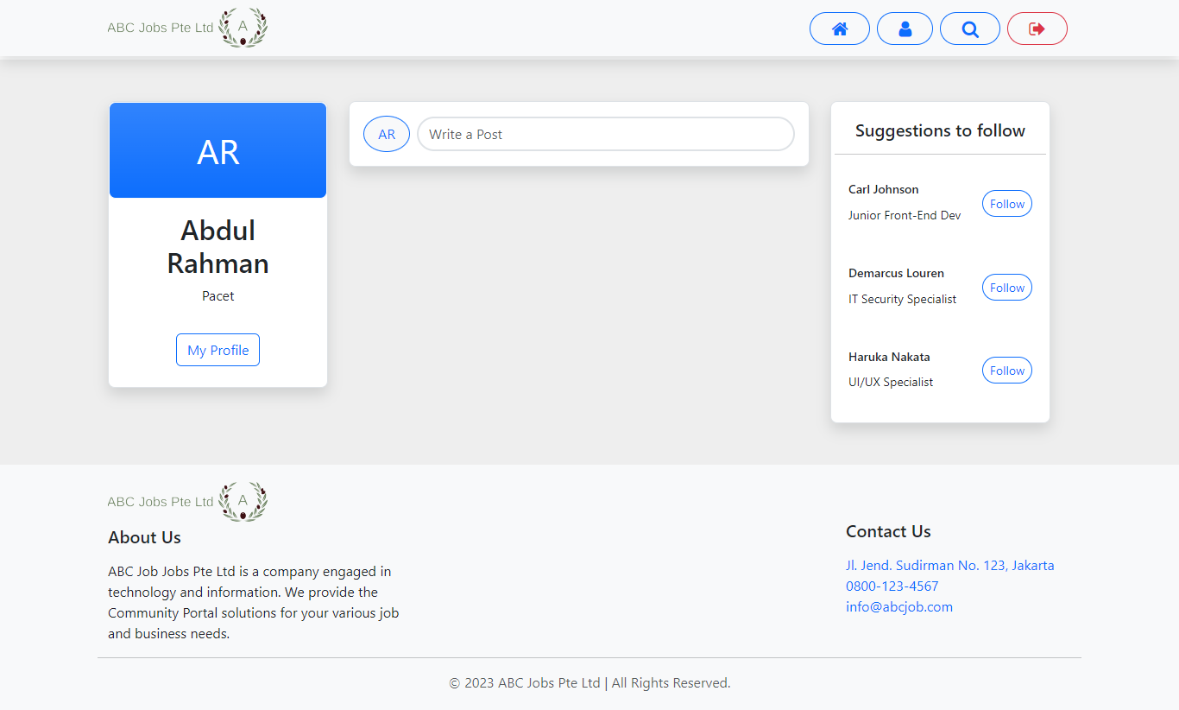

Evidence No. 2

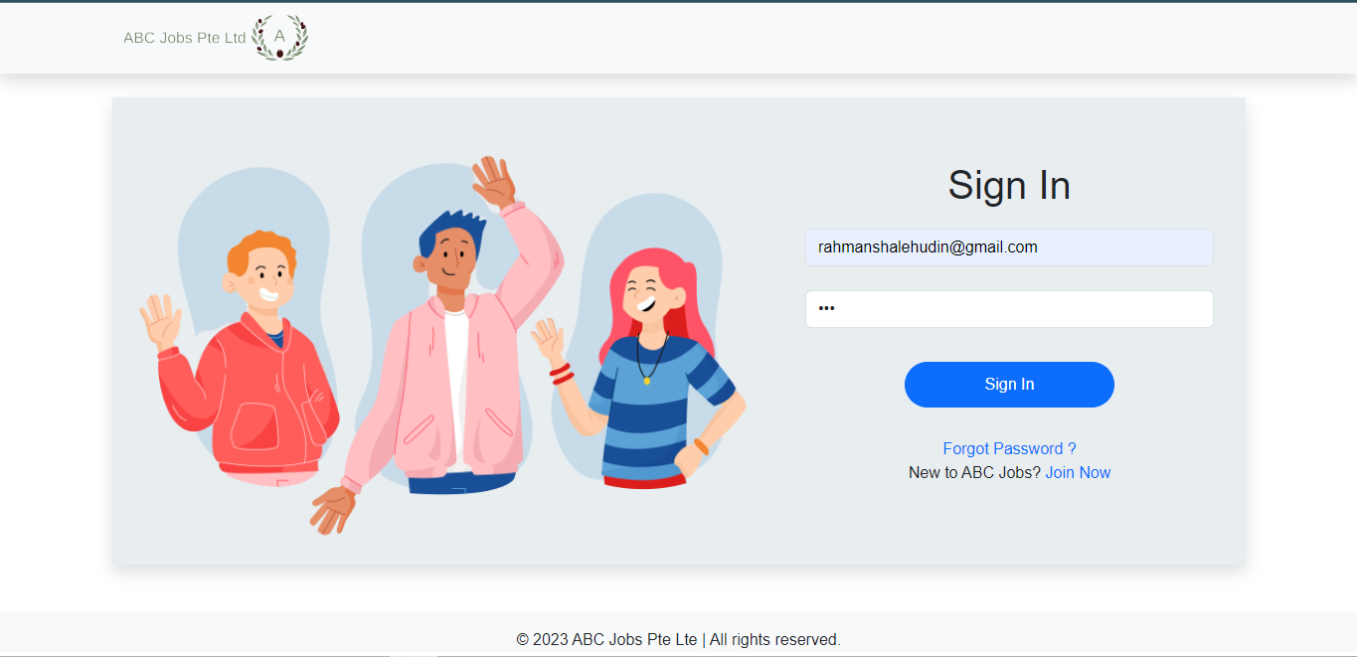

# Task 2: Tools, Process & Technologies

|  |  |  |  |  |  |  |  |  |  |  |
| --- | --- | --- | --- | --- | --- | --- | --- | --- | --- | --- |
| Issue Identification and Tracking Document | | | | | | | | | | |
| Created By: | | | Agung Yuda | | Last Update By: Agung Yuda | | |  | | |
| Date Created: | | | 05-08-2023 | | Last Revision Date: 18-08-2023 | | |  | | |
| Issue No. | Issue Description | Issue Type | Identified By | Date Identified | Issue Assigned To | Target Resolution Date | Priority | Status | Date Resolved | Resolution Description |
| 1 | User Thread Not Showing in the Dashboard | Technical Issues | Customer | 14-8-2023 | Software Development  Team | 15-8-2023 | High | Resolved | 15-8-2023 | Correcting Items and Var in JSP Page |
| 2 | Invalid login details error not displayed | Technical Issue | Software Tester Team | 07-8-2023 | Software Development  Team | 08-8-2023 | High | Resolved | 08-8-2023 | Adding the code of message |

1. **Problem Investigation**

Techniques = Root Cause Analysis

Tool = Brainstorming

Process:

1. Utilize a Fishbone Diagram to systematically analyze the root causes of identified issues.
2. Identify major categories (bones) that could contribute to the issue, such as people, process, equipment, environment, and materials.
3. Drill down into each category to identify potential root causes that might lead to the observed problem.
4. Encourage cross-functional discussions to gather insights from various team members.
5. Prioritize root causes based on their significance and relevance to the issue, enabling targeted corrective actions. Problem Resolution.

# Task 3: Investigate & Diagnose

1. **Investigate the problem**

Issue 1: User Thread Not Showing in the Dashboard

* Issue Description: User thread is not displaying on the dashboard.
* Issue Type: Technical Issues
* Identified By: Customer
* Date Identified: 14-8-2023
* Issue Assigned To: Software Development Team
* Target Resolution Date: 15-8-2023

**Investigation:** To investigate this issue, the software development team needs to analyze the dashboard's functionality related to user thread display. They should review the relevant code, database queries, and any recent changes made to the system. It's essential to understand whether this is a data-related problem, a code bug, or a configuration issue that prevents user threads from showing on the dashboard.

Issue 2: Invalid Login Details Error Not Displayed

* Issue Description: The invalid login details error message is not displayed.
* Issue Type: Technical Issue
* Identified By: Software Tester Team
* Date Identified: 07-8-2023
* Issue Assigned To: Software Development Team
* Target Resolution Date: 08-8-2023

Investigation: The software development team must examine the login functionality and error handling process to investigate this issue. They should review the code responsible for validating login details and displaying error messages. The investigation aims to determine why the system fails to display the error message when invalid login details are provided.

1. **Diagnose the problem**

Issue 1: User Thread Not Showing in the Dashboard

Diagnosis: After investigating the issue, it was found that a recent code update introduced a bug in the code responsible for fetching and displaying user threads on the dashboard. The bug caused the system to skip retrieving user threads from the database, leading to their absence on the dashboard.

Diagnosis Steps: The development team identified the specific code segment responsible for querying and displaying user threads. Through code review and debugging, they traced the issue to an incorrect SQL query that failed to retrieve the necessary data. This led to an empty result set, resulting in the absence of user threads on the dashboard.

Diagnosing the Root Cause of the Problem through Debugging:

Debugging is a crucial step in diagnosing software-related issues. In this case, the development team utilized debugging techniques to uncover the root cause of the problem:

* Code Inspection: Developers reviewed the code responsible for fetching user threads and analyzed the logic behind the data retrieval process.
* Print Statements: The team strategically inserted print statements within the code to track the data flow and identify where the process was breaking.
* Variable Inspection: Debugging tools were used to inspect the values of variables and database queries during runtime to identify discrepancies or errors.
* Step-by-Step Execution: Developers executed the code step by step, monitoring variable values and code behavior at each stage to pinpoint the moment when the data retrieval failed.

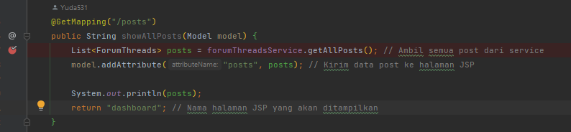

Issue 2: Invalid Login Details Error Not Displayed

Diagnosis: After investigating the issue, it was identified that the error message display code is not being executed when invalid login details are entered. As a result, users need to receive feedback when their login attempts fail.

Diagnosis Steps: The development team traced the issue to an oversight in the login validation process:

* Code Review: The developers reviewed the code responsible for validating login details and identified that the error message display function was not being called within the code block handling invalid login attempts.
* Conditional Logic Issue: Upon further examination, it was discovered that a conditional statement intended to trigger the error message display was not evaluated correctly due to a typo in the code.
* Test Scenarios: The development team executed test scenarios with deliberately incorrect login details to replicate the problem and observe the system's behavior. They confirmed that the error message was not appearing as expected.

Debugging was essential in uncovering the root cause of this issue:

* Code Inspection: Developers reviewed the login validation code and identified the conditional logic governing the error message display.
* Debugging Statements: Print statements were inserted to confirm the flow of execution and identify whether the code block for the error message display was being entered.
* Condition Evaluation: Debugging tools were used to inspect the values of variables and expressions during runtime to pinpoint the moment when the conditional statement failed to evaluate correctly.
* By leveraging debugging techniques, the development team identified the root cause—conditional statement error—and rectified the issue. The error message for invalid login details was reinstated, providing users with the necessary feedback.

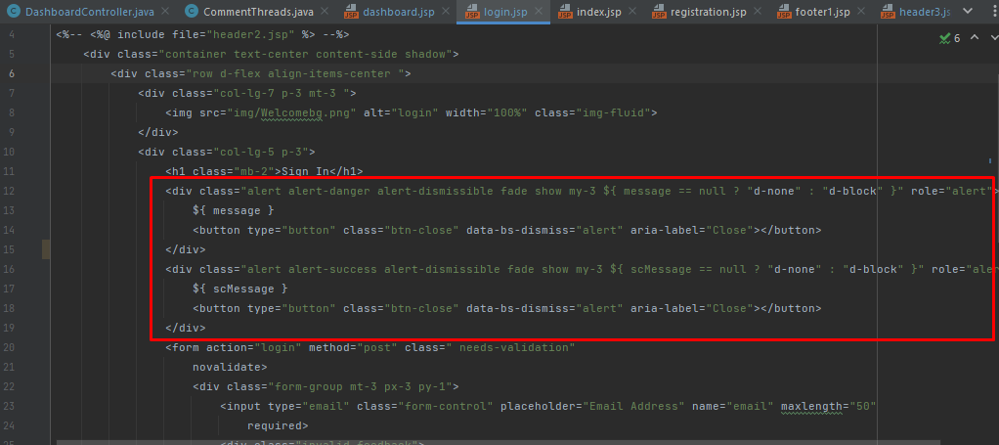

# Task 4: Explain Prioritize

## Priorities and categories problems:

**Tier 1: Low priority issues**

* The first tier is for basic or minor problems.
* Handle low-priority incidents that do not impact the business. It is easy to solve and repeats a lot. Usually, incidents here are converted into incident models.

**Tier 2:** **medium priority issues**

* The second tier is the major problems.
* Dealing with incidents that impact users but not the business as a whole. These incidents require more skill or access to resolve.

**Tier 3:** **High Priority Issues**

* The third tier is the critical problem
* Manage incidents that affect the entire organization and multiple users. These incidents are high priority and often enter the Major Incident Response process.

**Problems Categories Diagram:**

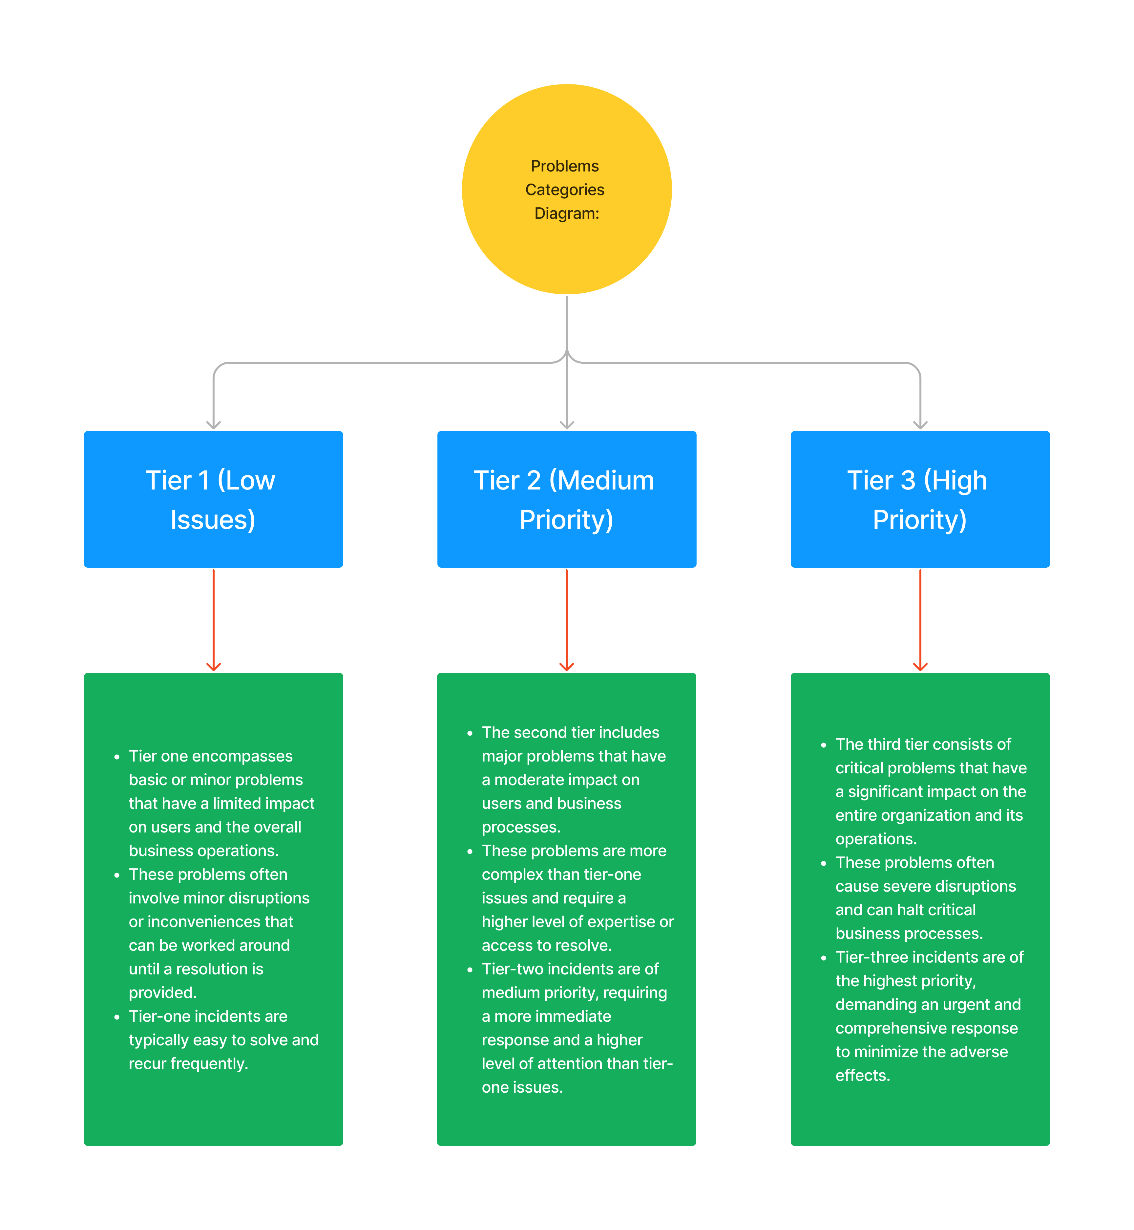

# Task 5: Problem Management Solution

**Solution for Thread not showing in The Dashboard:**

1. Debug create_thread endpoint
2. Check the logic in create_thread endpoint
3. Ensure in the JSP have a correct var and items it will sync with backend and database.
4. 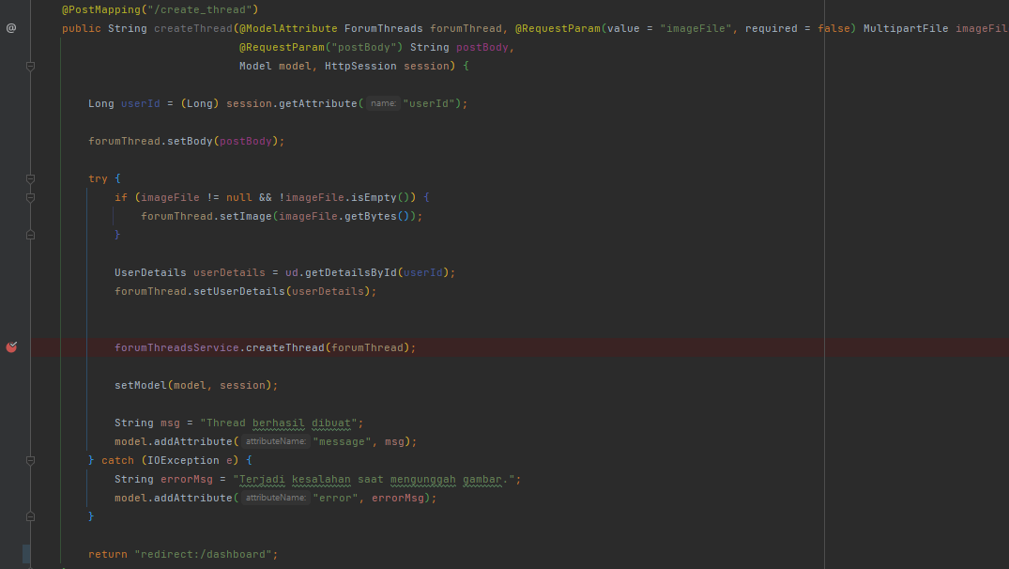Ensure have implement endpoint to call all thread

Debug is success and not have a problem with endpoint

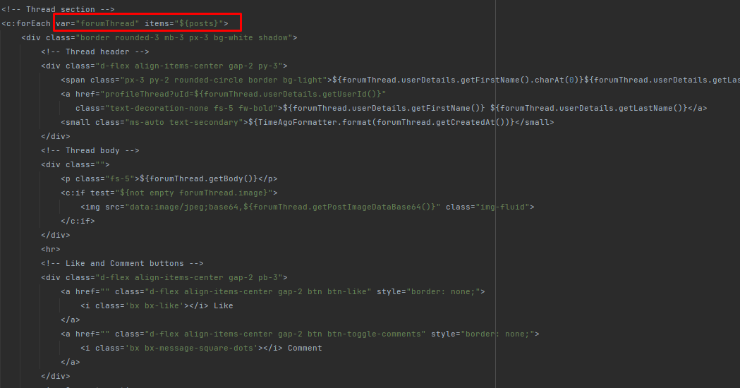

Identify the var and items. And check the attribute in the thread

And this is the endpoint for call the thread

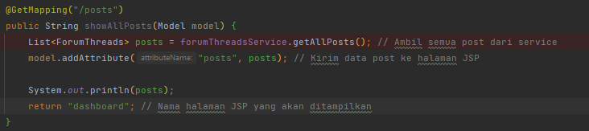

**Solution for Invalid login details error not displayed:**

1. Debug Login Endpoint
2. Ensure the data user has saved in database
3. Identify the login.jsp have a correct variable to synchronize with backend
4. Ensure the login.jsp have a code for show the message

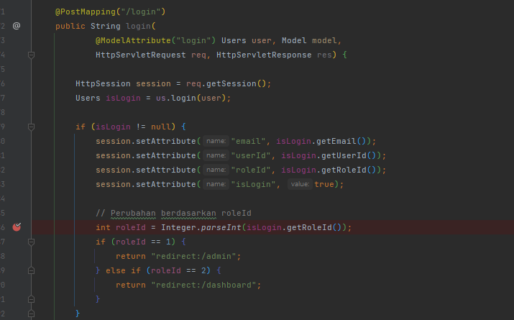

Debug Login Endpoint. Ensure we have a correct logic

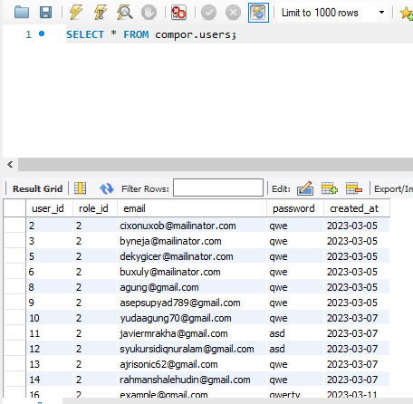

The Data of User already registered has saved to database

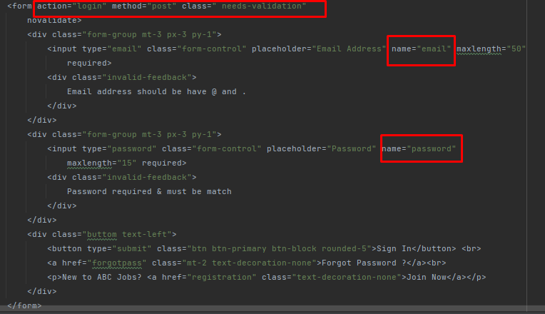

Add the message code if error login

Ensure All the variables is correct

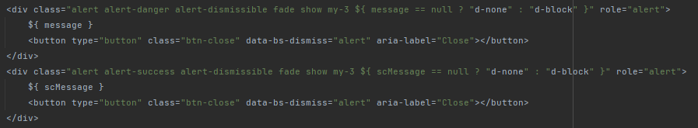

|  |  |  |  |  |  |  |
| --- | --- | --- | --- | --- | --- | --- |
| Known Error Database | | | | | | |
| **Ticket no.** | Issue Description | Issue Type | Root Cause | Workaround | Status | Date Resolve |
| 1. | User Thread Not Showing in the Dashboard | Technical Issues | There is mistake items and var in JSP Page | Correcting Items and Var in JSP Page | Resolved | 15-8-2023 |
| 2 | Invalid login details error not displayed | Technical Issue | Code for Error message is empty | Adding the code of message | Resolved | 08-8-2023 |

# Task 6: Systems will be implemented

**Brainstorming Method:**

The brainstorming method will be implemented to facilitate effective problem-solving and idea generation. Brainstorming is a collaborative and creative approach that encourages team members to contribute ideas, suggestions, and potential solutions to identified issues. By leveraging the team's collective expertise and diverse perspectives, the brainstorming method can lead to innovative and viable solutions.

**Steps of Brainstorming:**

1. **Problem Statement:** Clearly define the problem or challenge to be addressed. In problem management, this could involve issues related to incident resolution, system performance, or user experience.
2. **Team Collaboration:** Gather a diverse team of individuals with different skills, backgrounds, and expertise relevant to the problem. This diversity can bring unique viewpoints and insights to the brainstorming session.
3. **Idea Generation:** Encourage participants to share their ideas and suggestions about the problem. This can involve both practical and creative ideas. Encourage an open and non-judgmental atmosphere to foster free expression.
4. **Quantity Over Quality:** Emphasize generating a high amount of ideas initially without focusing on evaluating their feasibility or quality. The aim is to promote a flow of ideas without constraints.
5. **No Criticism:** During the brainstorming session, refrain from critiquing or evaluating ideas. All contributions should be accepted and recorded without judgment.
6. **Build on Ideas:** Encourage participants to build on the ideas presented by others. This can lead to the developing of more refined and innovative solutions through collaboration.
7. **Divergence and Convergence:** Begin with a divergent phase where various ideas are generated. Then, move into a convergent phase where the team narrows the list and identifies the most promising ideas.
8. **Capture Ideas:** Record all generated ideas on a whiteboard, flipchart, or digital document. This documentation ensures no idea is lost and provides a visual overview of the brainstorming outcomes.

**Benefits of Brainstorming:**

* **Diverse Solutions:** Brainstorming encourages the generation of various solutions by involving different perspectives and backgrounds.
* **Innovation:** Creative thinking during brainstorming can lead to innovative approaches that might have yet to be considered initially.
* **Team Collaboration:** Brainstorming promotes teamwork and collaboration, fostering a sense of shared responsibility for problem-solving.
* **Engagement:** Team members become engaged and invested in the solution-finding process, enhancing their commitment to implementing the chosen solutions.

**Implementation Plan:**

* Conduct regular brainstorming sessions as part of problem-management meetings or workshops.
* Provide a conducive environment that encourages open sharing of ideas.
* Assign a facilitator to guide the brainstorming process, ensuring everyone has a chance to contribute.
* Document all ideas for later evaluation and selection of viable solutions.

# Task 7: Best Practices in Problem Management

Navigating problem management with adherence to best practices and industry standards is crucial for maintaining operational efficiency and delivering exceptional service. Here are five fundamental best practices to guide effective problem management:

1. **Clear Separation of Clients and Incident Handlers:** To enforce a transparent and impartial problem-resolution process, it is important to establish a clear separation between the client and the individual responsible for handling incidents. Ensuring that the incident handlers are distinct from the affected clients prevents potential conflicts of interest. This separation facilitates objective analysis, effective communication, and the unbiased pursuit of solutions. It is a cornerstone practice that fosters trust and assures clients that their concerns are addressed professionally and objectively.
2. **Establishment of a Known Errors Database:** A robust Known Errors database is pivotal for informed decision-making and continuous improvement. Every resolved incident should be meticulously documented in this database. Doing so creates a repository of historical incidents and their solutions, which becomes a valuable resource for future troubleshooting. The Known Errors database accelerates the resolution of recurring issues and supports proactive problem management. Patterns and trends identified from this database can drive preventive measures and systemic enhancements, minimizing the impact of potential problems.
3. **Root Cause Analysis and Resolution:** Addressing the symptoms of a problem is important, but it is equally crucial to identify and resolve the root cause. Conduct thorough root cause analysis to understand the underlying factors contributing to incidents. Targeting the root cause prevents the recurrence of similar issues and lays the groundwork for sustainable solutions. This practice improves service quality and demonstrates a commitment to delivering lasting results.
4. **Continuous Communication and Feedback Loop:** Effective problem management involves consistent communication with clients and stakeholders. Maintain an open feedback loop to keep clients informed about the status of incident resolution and any preventive measures being implemented. This transparent communication instills confidence in your problem-management process and shows clients their concerns are being taken seriously. Furthermore, client feedback provides invaluable insights for refining problem-management strategies and enhancing service delivery.
5. **Regular Review and Improvement:** Problem management is a dynamic process that requires continuous evaluation and improvement. Regularly review the efficiency of your problem management practices, analyzing metrics such as incident resolution time and client satisfaction. Use these insights to identify areas for enhancement, refine processes, and implement corrective actions as necessary. A culture of continuous improvement ensures that problem management remains adaptive and responsive to evolving challenges.

By embracing these best practices, organizations can elevate their problem-management capabilities, enhance customer satisfaction, and cultivate a resilience and proactive problem-solving culture.